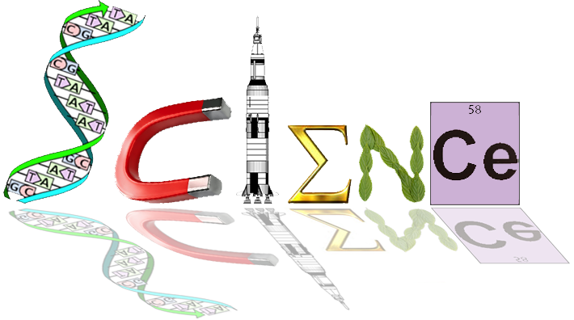

**Yr. 12 ATAR Human Biology Unit 3**

**Task 1: In Class Essay**

The role of Endocrine glands and the hormones they produce play a pivotal role in the control, function, and development of the Human body. Unfortunately due to this importance, when they do not function as required, the effects can be quite drastic.

Your task is to pick an endocrine disorder. The list below is a starting point but you may choose from outside of those options.

You will need to research the disorder and produce 1 A4 page of notes, back and front, hand written, to assist you in answering essay questions, Period 0 Friday the 17th (7.45am).

In your research you must explore:

* A general overview of the disease
* The role of associated hormones and any feedback loop they are involved in
* The effects on the body of the disorder or disease
* The symptoms associated with it
* Causes
* Treatments
* Any other critical information

You will be assessed on your written response, your notes that will be submitted, as well as your ability to reference in text on your accumulated notes page.

**List of common Endocrine disorders:**

[**Acromegaly**](https://www.endocrineweb.com/conditions/acromegaly/acromegaly-overview)

[**Addison's Disease**](https://www.endocrineweb.com/conditions/addisons-disease/addison-disease-adrenal-insufficiency-overview)

[Adrenal Cancer](https://www.endocrineweb.com/conditions/adrenal-cancer/diseases-adrenal-cortex-adrenal-cancer)

[Adrenal Disorders](https://www.endocrineweb.com/conditions/adrenal-disorders/all)

[Anaplastic Thyroid Cancer](https://www.endocrineweb.com/conditions/thyroid-cancer/thyroid-cancer-anaplastic-cancer)

[Cushing's Syndrome](https://www.endocrineweb.com/conditions/cushings-syndrome/diseases-adrenal-cortex-cushings-syndrome)

[De Quervain's Thyroiditis](https://www.endocrineweb.com/conditions/thyroid/thyroiditis)

[**Diabetes**](https://www.endocrineweb.com/conditions/diabetes/all)

[Follicular Thyroid Cancer](https://www.endocrineweb.com/conditions/thyroid-cancer/thyroid-cancer-follicular-cancer)

[**Goiters**](https://www.endocrineweb.com/conditions/goiters/goiters-abnormally-large-thyroid-glands)

[**Graves' Disease**](https://www.endocrineweb.com/conditions/graves-disease/graves-disease-overview)

[Growth Disorders](https://www.endocrineweb.com/conditions/growth-disorders/all)

[Growth Hormone Deficiency](https://www.endocrineweb.com/conditions/growth-disorders/growth-hormone-deficiency-basics)

[Hashimoto's Thyroiditis](https://www.endocrineweb.com/conditions/hashimotos-thyroiditis/hashimotos-thyroiditis-overview)

[Hurthle Cell Thyroid Cancer](https://www.endocrineweb.com/conditions/thyroid-cancer/hurthle-cell-thyroid-tumor)

[Hyperglycemia](https://www.endocrineweb.com/conditions/hyperglycemia/hyperglycemia-when-your-blood-glucose-level-goes-too-high)

[Hyperparathyroidism](https://www.endocrineweb.com/conditions/hyperparathyroidism/hyperparathyroidism)

[**Hyperthyroidism**](https://www.endocrineweb.com/conditions/hyperthyroidism/hyperthyroidism-overview-overactive-thyroid)

[Hypoglycemia](https://www.endocrineweb.com/conditions/hypoglycemia/hypoglycemia-overview)

[Hypoparathyroidism](https://www.endocrineweb.com/conditions/hypoparathyroidism/hypoparathyroidism)

[**Hypothyroidism**](https://www.endocrineweb.com/conditions/thyroid/hypothyroidism-too-little-thyroid-hormone)

[Medullary Thyroid Cancer](https://www.endocrineweb.com/conditions/thyroid-cancer/thyroid-cancer-medullary-cancer)

[**Metabolic Syndrome**](https://www.endocrineweb.com/conditions/metabolic-syndrome/all)

[**Osteoporosis**](https://www.endocrineweb.com/conditions/osteoporosis/osteoporosis-overview)

[Papillary Thyroid Cancer](https://www.endocrineweb.com/conditions/thyroid-cancer/papillary-thyroid-cancer)

[Parathyroid Diseases](https://www.endocrineweb.com/conditions/parathyroid-diseases/all)

[Pheochromocytoma](https://www.endocrineweb.com/conditions/pheochromocytoma/all)

[Pituitary Disorders](https://www.endocrineweb.com/conditions/pituitary-disorders/all)

[Pituitary Tumors](https://www.endocrineweb.com/conditions/pituitary-tumors/pituitary-tumors-overview)

[**Polycystic Ovary Syndrome**](https://www.endocrineweb.com/conditions/reproduction/polycystic-ovary-syndrome-pcos-female-teenagers-women)

Thyroid Cancer

[Thyroid Diseases](https://www.endocrineweb.com/conditions/thyroid/all)

[Thyroiditis](https://www.endocrineweb.com/conditions/thyroiditis)

[**Turner Syndrome**](https://www.endocrineweb.com/conditions/turner-syndrome/turner-syndrome-overview)

* The bolded examples are common WACE context